HDFLook Introduction

The purpose of these exercises is to become familiar with some of the MODIS atmosphere products while simultaneously becoming familiar with some of the HDFLook
functionality.

To start the program type HDFLook (exactly as written) in the xwindow.
When HDFLook opens for the first time you will see the HDF_read_files window. The HDF_read_files window is used to navigate between directories to find the files you want to load.
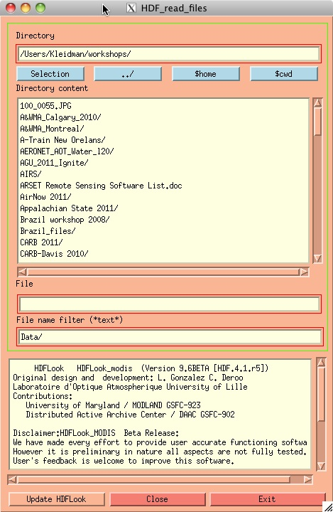

Navigate to the directory where the files are located. Once you see the list of files highlight the file to be loaded. For this exercise the first file we will load is: MOD04_L2.A2008200.1930.005.2008201110544.hdf

A second window will now open showing the list of parameters in the file and the controls for the visualization.

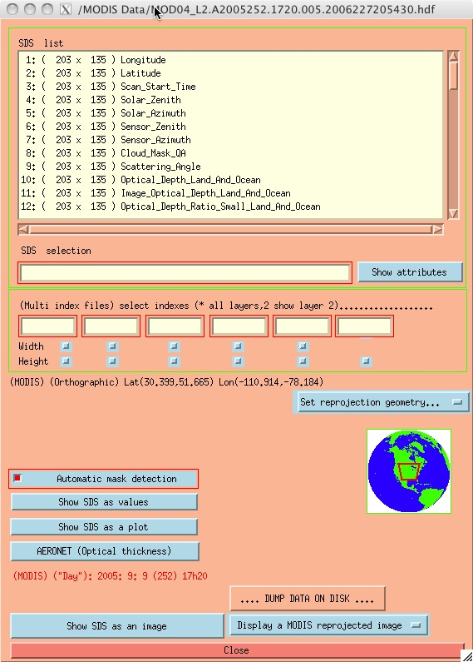

Once it is loaded the file name will appear in the title bar at the top of the second window. In this window will be the list of all the parameters contained in this file.

If the windows are too large to fit completely on your screen quit the application.
Restart using the command HDFLook –z 80. This will zoom the display windows to 80% of normal size.

HDFLook Functionality
HDFLook has functionality to display data as both raw rectangular images and reprojected images. Controls for raw image display or on the left-hand side of the parameter selection window. Reprojected images are displayed using controls on the right-hand side.

