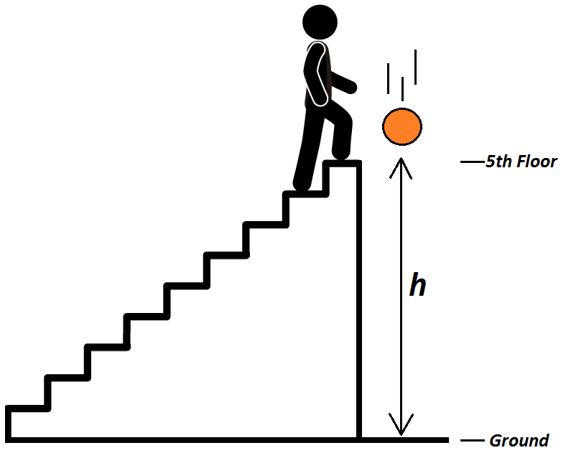
$$h=v_{0}t+\frac{1}{2}at^{2}$$
v₀ = 0
a = 9.81 m/sec²
Trial | Time (sec)
1 | 2.28
2 | 2.58
3 | 2.26
4 | 2.21
5 | 2.30

Average time = 2.326 sec
Standard deviation of data = .1016
Height = 26.537 ± 2.318 meters ≈ 87 ± 7.5 feet

