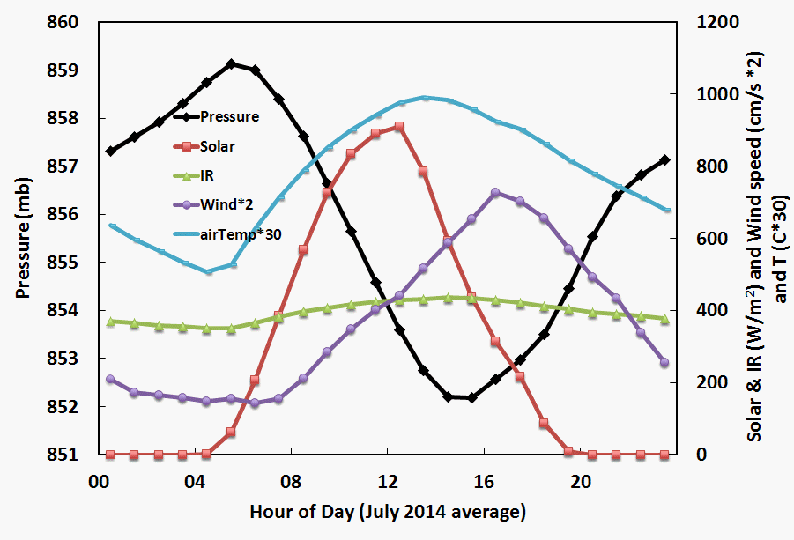
Figure 1. Diel average meteorology from at the UNR weather station.
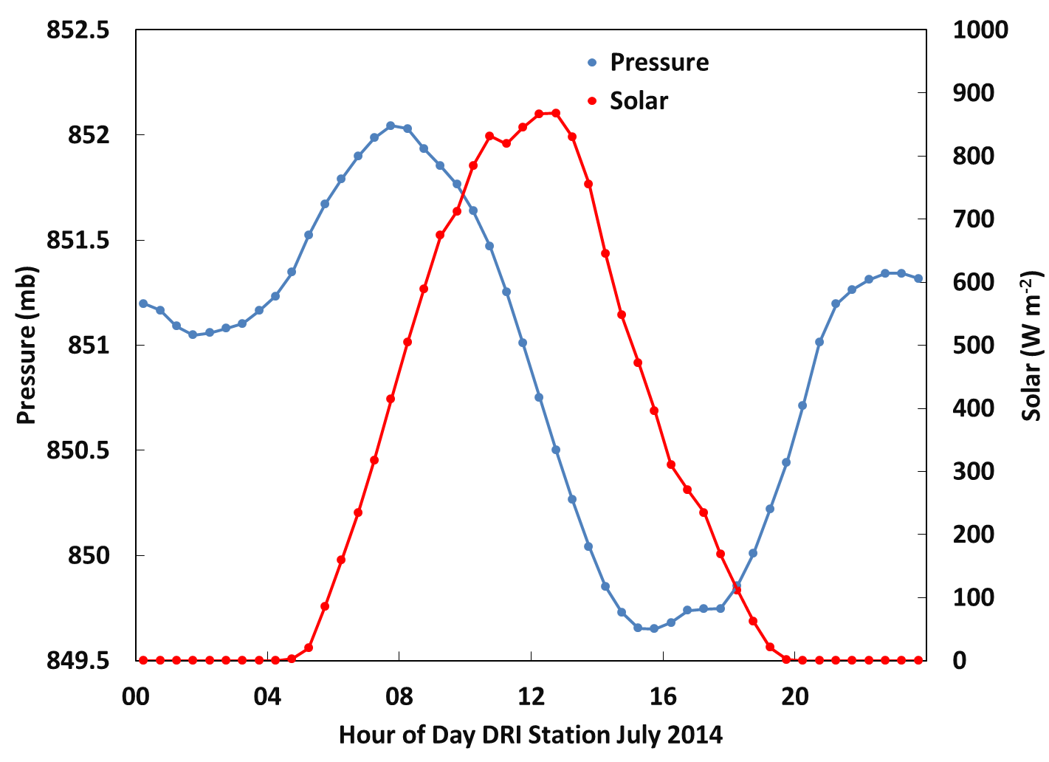
Figure 2. Diel average meteorology for the DRI weather station.

