Column Aerosol Optical Above Reno on June 1st 2012: A Case of Secondary Organic Aerosol Impact?

First describe AERONET: What is AERONET? How is AOD measured?
Then describe the HYSPLIT model and what it provides.
What did AERONET show for 1 June 2012? Discuss Figures 1 and 2.
Interpret the 17:00 UTC back trajectory. Figure 3 discussion.
Compare and contrast trajectories at 17:00 and 21:00 UTC. Figure 4 discussion.
Summary: Why did the AOD increase by about a factor of 2 from 17:00 UTC to 21:00 UTC?

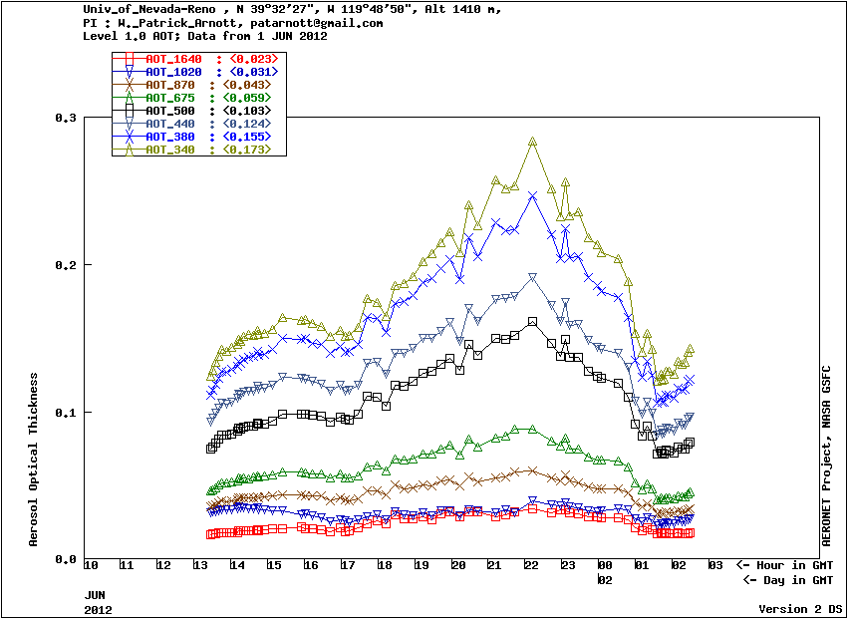
Figure 1. UNR AERONET AOD for 1 June 2012.

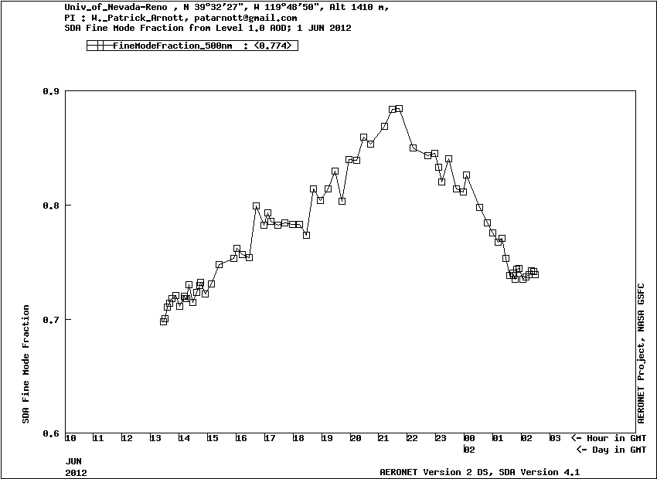
Figure 2. Fine mode fraction for 1 June 2012 from AERONET.

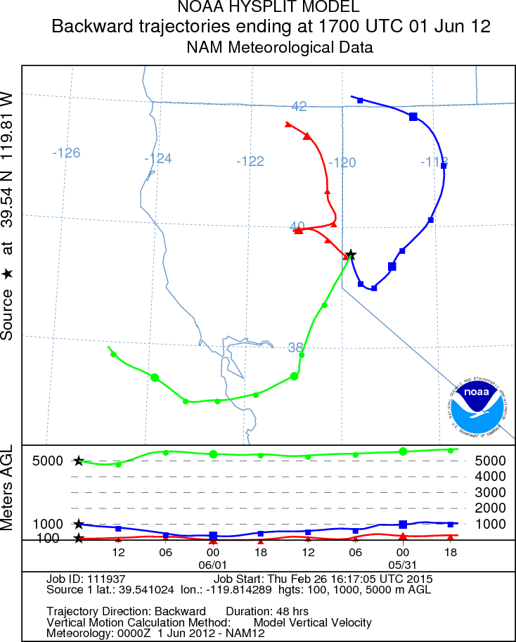
Figure 3. HYSPLIT backtrajectory analysis for 17:00 UTC on 1 June 2012.

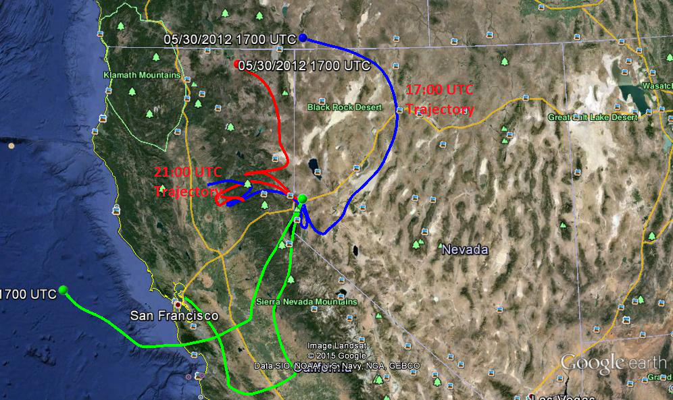
Figure 4. HYSPLIT model back trajectories for 17:00 UTC and 21:00 UTC on 1 June 2012.

