Title: Assignment 1 Lapse Rate Study for Reno for July 2014
Introduction
…
Sanchez et al, 2013, showed that temperature inversions in Guadalajara Mexico were associated with severe asthmatic problems. …

1. Time Series Analysis

2. Statistical Description of the Lapse Rate
Figure 1 shows the histogram of lapse rate values for December 2014. The most common value is 10 K/km. This value occurs because …..

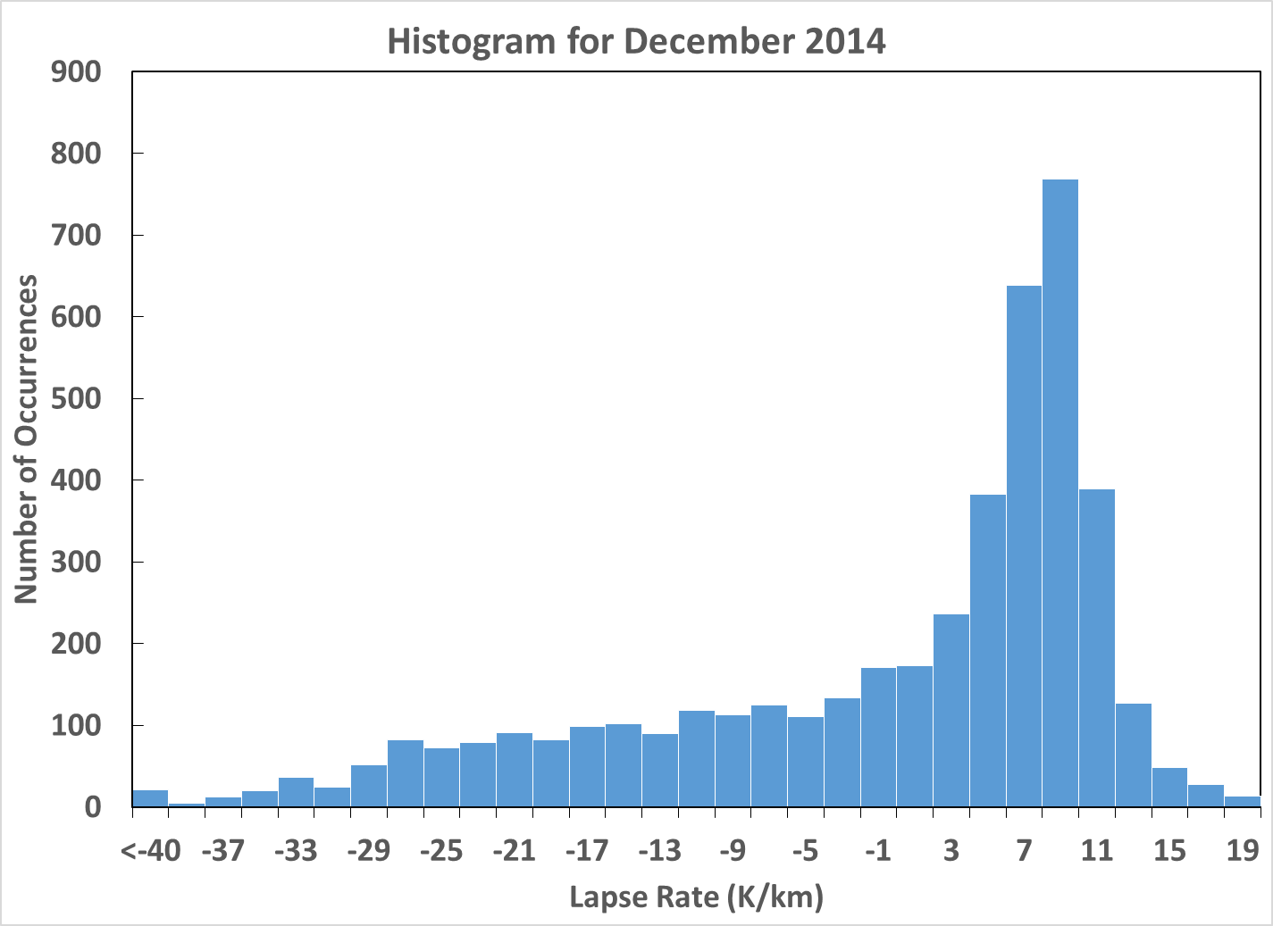
Figure 1. Histograms of 10 minute intervals for lapse rate in December 2014.

Conclusion

References
Sanchez, Herman, et al, 2013. Respritory problems due to inversions. Journal of Environmental Protection Vol 2, pages 234-244.

