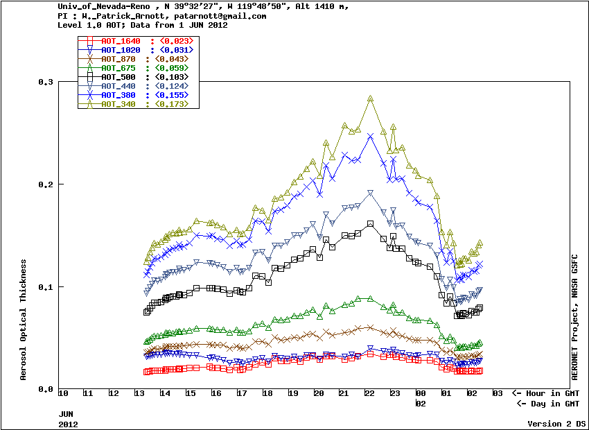
Figure 1. Spectral aerosol optical depth on 1 June 2012.

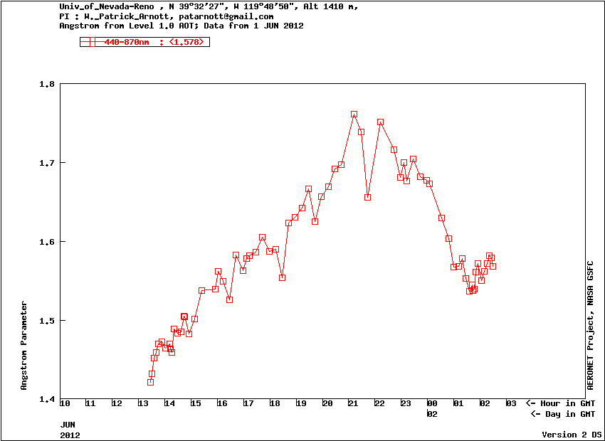
Figure 2. Angstrom exponent for 1 June 2012.

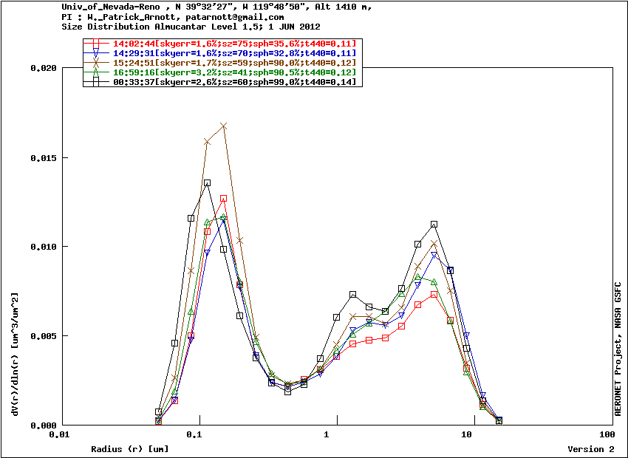Figure 3. Retrieved aerosol size distribution for 1 June 2012.

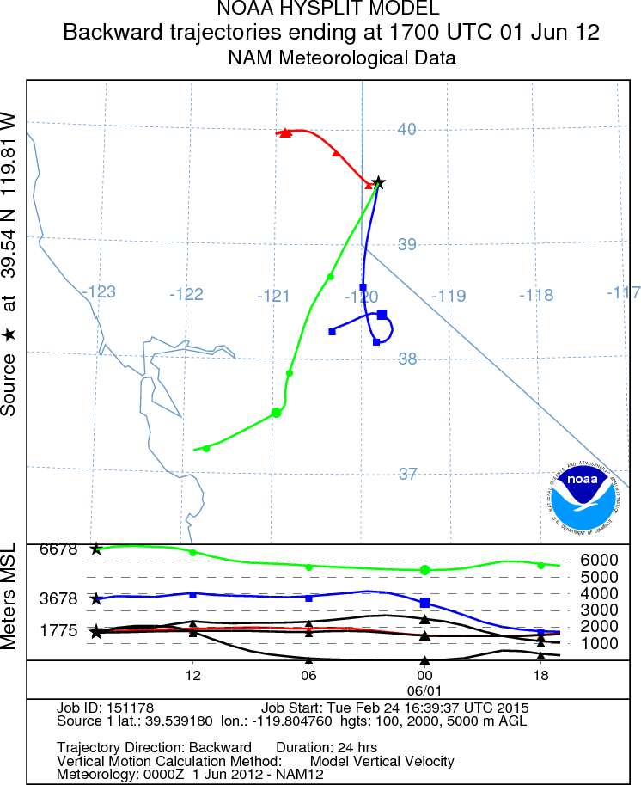
Figure 4. Backtrajectory analysis from Reno at 17:00 UTC on 1 June 2012.

