Homework 6 Chapter 4 Problems ATMS 317 – Spring 2026
Student:

1.
Consider northerly geostrophic flow of 50 m/s associated with the 200 mb surface.
A) Sketch height contours that would give this type of flow, labeling one contour with Φ and the other with Φ + dΦ where Φ is the geopotential and dΦ > 0.

B) Assume that these contours are separated by a distance of 100 km, and are at a latitude of 40 degrees. Calculate the height difference in meters for these contours for the observed wind speed.

2.
A) Derive an expression for the geostrophic zonal wind speed at 200 mb in terms of the meridional gradient of the mean virtual temperature between the 1000 mb and 200 mb levels. Assume that the surface pressure is 1000 mb and the Coriolis parameter is f. Express gradient in terms of the Earth’s radius R_{E} and the latitude φ. That is, show that

$u_{g}=-\frac{\ln\left(5\right) R_{D}}{fR_{E}}\frac{∂\overline{T} }{∂ϕ}$ ,

where R_{D} is the gas constant for dry air.

B) Use the finite difference approach to estimate the mean virtual temperature difference for a geostrophic wind speed u_{g} = 30 m/s. Assume a latitude of 40 degrees centered between 30 degrees and 50 degrees.

4.
This figure is from Pivotal Weather and depicts the variable ω = dP/dt as colors along with the 700 mb height contours. What is the vertical motion (updraft or downdraft) near Reno? Explain.

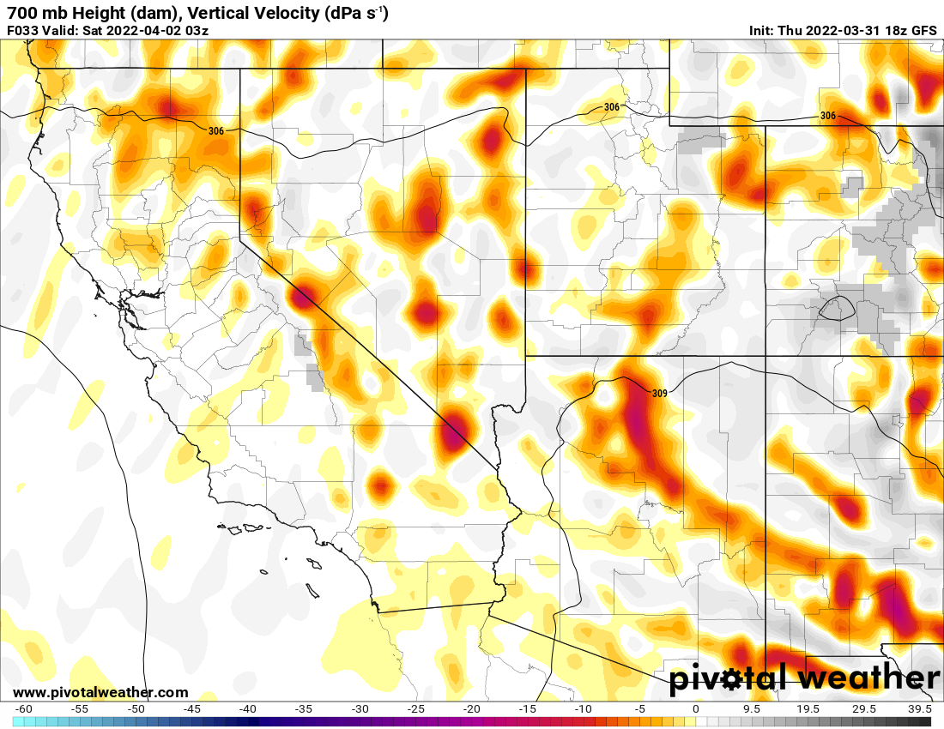

5. Chapter 4 problem 4.2
4.2. Hurricanes are axisymmetric disturbances (i.e. their structure is symmetric about the center). An Atlantic hurricane is located over the Caribbean Sea (latitude 26°N). Balanced wind speeds of 60ms⁻¹ are found, at 950mb, at a station 200 km from the center.
(a) What is the Rossby number of the flow associated with this storm? Explain your reasoning.

(b) Based upon your answer to (a), what terms in the natural coordinate equation of motion are balanced in this flow? Explain.

(c) If the 950mb geopotential height at the station is 367 m, what is the sea-level pressure at the eye of the hurricane? Show your work.

(d) Derive an expression for the ageostrophic wind in such a storm in terms of f, the pressure gradient force, and the radius of curvature (R).

(e) Calculate the ageostrophic wind speed at the station. How large would the radius of the hurricane have to be before the flow around it were in approximate geostrophic balance? Explain.

6. Chapter 4 problem 4.10
4.10. You have the misfortune of being shipwrecked on a small island in the central Pacific Ocean (latitude 40°N). On a certain day you observe the clouds at three distinct levels in the atmosphere. The lowest-level clouds are moving from north to south. The middle-level clouds are moving from west to east. The upper-level clouds are also moving from north to south. Assume all the clouds are propelled by geostrophic winds. How will the lapse rate over the island change as the day progresses? Explain your answer.

7. Chapter 4 problem 4.8.a.
4.8. (a) Physically explain (with reference to horizontal forces) why the wind speed is sub geostrophic in a trough and super geostrophic in a ridge.

