Laboratory 2: Infrared radiation in the Earth’s Atmosphere
Student Name: Date:

PURPOSE:
The purpose of this laboratory experience is to become familiar with infrared radiation in the Earth’s climate system, and to learn how to prepare graphics for a report of your findings.

OBJECTIVES:
Use a model of infrared radiation in the atmosphere to find out the following:
- The effects of water vapor and carbon dioxide on the downwelling IR for our current atmospheric conditions
- Appreciate the amount of downwelling IR at the surface when altostratus clouds are above head
- The effect on the outgoing IR at the top of the atmosphere as the carbon dioxide concentration increases, to study the instantaneous radiative forcing by this gas
- The surface temperature increase necessary to counter the IR radiative forcing by CO2 with the atmospheric water vapor concentration held at constant relative humidity (water vapor concentration increases with surface temperature as is likely for the atmosphere)

LET’S GET IT DONE!
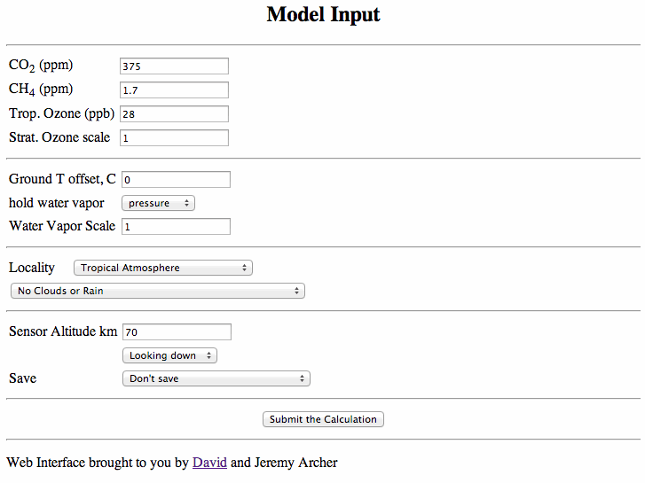
Go to http://forecast.uchicago.edu/Projects/modtran.orig.html. This website allows us to use MODTRAN to calculate IR in the atmosphere.

PROBLEM 1: Role of CO2 and H20 in determining the downwelling IR at the surface
30 points

Instructions
Go to the website.
Choose:
CO2 (ppm) 400 ppm
Locality 1976 U.S. Standard Atmosphere
Sensor Altitude km 0
Looking up
Submit the calculation

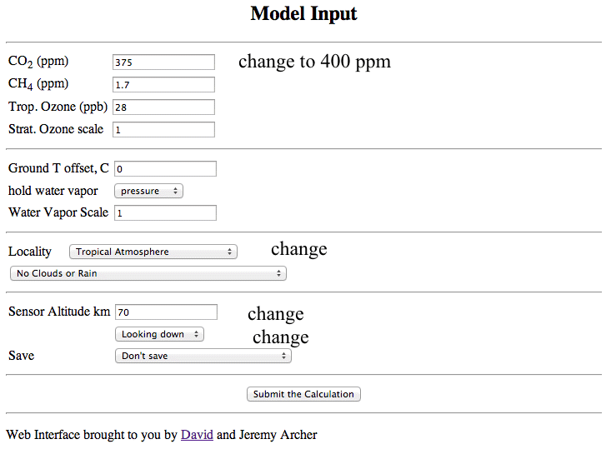
Figure 1. Make the changes where shown.

a. Submit the calculation. Record the downwelling IR at the surface.

I_{out} =

Note that this radiation is present day at night. Considering sunlight is present in Reno for about 1/2 the day, how does I_{out} qualitatively compare with the amount of sunlight?

b. Double CO2 to 800 ppm. Record the downwelling IR at the surface.

I_{out} =

What is the radiative forcing caused by doubling CO2 concentration?

c. Reset CO2 to 400 ppm. Then double the water vapor scale (from 1 to 2).

I_{out} =

What is the radiative forcing caused by doubling H20 concentration? (subtract c from a).

d. Reset the water vapor scale to 1. Add an altostratus cloud. Submit the calculation.
I_{out} =

What is the radiative forcing caused by the altostratus cloud? (subtract d from a).

e. Now rank in order of decreasing effect the agent (CO2, H20 vapor, altostratus cloud) that increases the downwelling IR at the surface the most. Explain why it is warmer at night when an altostratus cloud is overhead.

Problem 2: Increasing surface temperature to maintain the IR radiative balance as CO2 increases, with feedback to water vapor.
70 points

We will now put the IR sensor at the top of the atmosphere, looking down so it can measure the IR radiation emitted to space by the Earth surface in conjunction with the atmosphere.

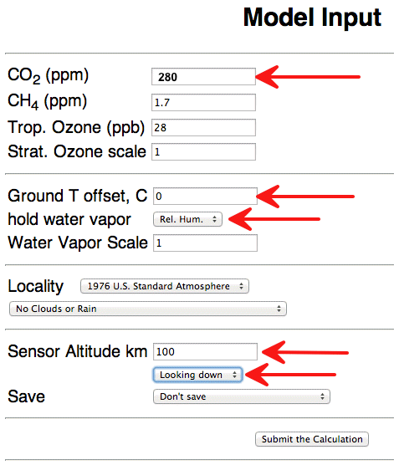

a. Here is how we study the feedback necessary to keep the outgoing infrared radiation the same as the CO2 concentration increases. Set up the model as shown with preindustrial concentration of CO2 = 280 ppm. Calculate the outgoing IR radiation at the top of the atmosphere using this set up. You should get

I_{out} = 259.992 W/m² for the surface temperature, T = 288.20 Kelvins.

Increase CO2 to 400 ppm, the current value. Rerun the calculation. You should get I_{out} = 258.045 W/m². For a radiative balance the surface temperature needs to go up so that the outgoing IR remains at the preindustrial value. Adjust the ground temperature offset until you get the same value for outgoing flux as in the preindustrial case. You should get a ground temperature offset of 0.65 C, and ground temperature T = 288.85, to get the same IR.

b. Repeat the same procedure for each of the CO2 concentrations in the following table. Fill in the ground temperature offset values you find by running the model to keep I_{out} = 259.992 W/m².

CO2 Concentration (ppm) | Ground Offset Temperature (C)
400 | 0.65
450
500
550
600
650
700
750
800
900
1000
1100

c. Copy and paste your table values into Excel. Make a 'professional' graph of the CO2 concentration on the x-axis and the ground offset temperature on the y-axis. You have now completed your first climate change model. Paste your graph as a picture into this document below.

d. Refer to your graph. Summarize why the ground temperature must increase as the CO2 concentration goes up in this model. Keep in mind that this model has built in the water vapor concentration increase with ground temperature as well, as is likely to happen in the real atmosphere. Does global warming caused by enhancement of the greenhouse effect seem likely?

e. How might cloud amount changes affect your interpretation in part d?

